Show Planning
7 - 5 days Before Live
Hey!! I’m SO EXCITED for your Aloette girls night on X! I am going to help you have a blast with your friends. I’m going to walk you through it and keep it super simple! Watch this video and once you’ve watched it I’ll add you to the Facebook Group on (Day party starts) & get this party started! Click here - https://youtu.be/IRGqpRVDmpo- Noel’s VIDEO EXAMPLE - you can make your own

Keyword (from video) sent by Hostess
Yay! I’ll get you into the group on (start date) can you send me a profile picture that I can use in the cover photo please and thank you!

5 days before Add all the hostesses together in a group chat.
(Voice note) Hey, ladies!! I am so pumped for this battle of the hostesses on X Night! We are going to have a blast. So I thought I would get this group chat started so you can all meet each other, but also so I can hostess coach you all together! This way no one has an unfair advantage! You all are getting the same information at the same time. This is also so I don’t miss sending info!

So what I would love for you ladies to do is just take a moment and introduce yourselves. Let us know where you’re from and what your favorite Aloette product is and/or what you’re excited to get with your hostess rewards!

So some fun info! This is a friendly Battle so there are going to be points awarded for different things like attendance, orders placed and parties booked. The hostess with the most points will be receiving the PRODUCT for free from me! When you have 8 guests attend live you’ll get PRODUCT!

For our guests, for every 10 that join us on the party Live, i’m going to draw for a free full size product! I will have everything together and will get you ladies into the group tomorrow morning!

ADD THEM TO THE GROUP

IN A VOICE NOTE- Hey, ladies!! I wanted to give you some extra tips to make sure you each have a successful party. It’s really important to send your friends private messages to invite them so it’s personal. We want them to feel really special! Personal messages will make sure the invite doesn’t get lost– you can call, text, email whatever works for you.

After you’ve invited your guests, it would be amazing if you could take a moment to post and let your friends know WHY you're hosting and what you love about Aloette!

And don’t forget to like, comment and engage on all the group posts! Your excitement is contagious. PLUS will bump the post into your friends facebook feed when you comment. If you have anyone that you haven't invited yet, please send her an invite and a private message. Don’t make someone wonder why you didn’t invite them to this FUN girls night! I am so excited to pamper you - I cannot wait!

4 days before live
Send message:
We’re getting closer! I’m so excited! Today, if you haven’t already, you can go into the group and start to invite all your guests. Here’s something you can copy and paste and send to each of them in a private personal message so that we are sure they feel special because you took the time to message them! So copy and paste something like this:

“Hey, (name)!! I want to invite you into my Aloette party group! This is going to be so much fun! (Consultant name) will be doing a prize giveaway when we have 8 ladies attending live & girls night is X night at Xpm on FB Live! Trust me you will be so glad you attended live!! Can you be on the live?”

If they can’t make it live, please still encourage them to join the group!!

Facebook Group Set Up
SCHEDULE your posts ahead of time so they are sprinkled throughout each day. GO LIVE into the group using FB live OR stream into the FB group through zoom the night of the show so the presentation is automatically there & guests can watch the replay if they couldn’t make it!

Be sure to Schedule ALL POSTS - sprinkle them into each day at different times. 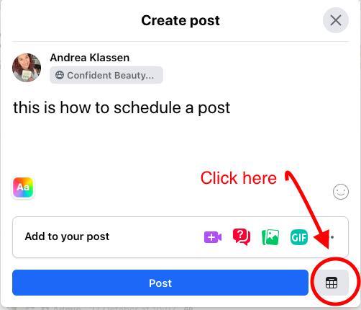

2 Days before LIVE SHOW
(Voice note to hostesses)
Hey!!
It looks like you’ve got some friends in the group - that’s great! Take a look at the list of members and count how many of your friends are in the group. The BIGGEST tip I can give you - is CONFIRM your guests for X night, just expecting them to show up will leave you very disappointed. So Asking, “Can you come? Are you coming? You’ll have so much fun!” This will tell you who to expect - we want to aim for 8+ guests attending to get you the extra bonuses!! Can’t wait!! If you have any questions I’m here to help!

1 Day Before Live Show
(send in text)
Woohoo Tomorrow is the BIG day!! How many have you confirmed that said yes they are coming in a private message?

- Wait for a reply

(Voice note to them)
AMAZING
It’s normal for last minute cancellations too but you are doing amazing, and just keep doing what you’re doing to remind, and follow up!!
What will make or break the show is reminders! Because we all tend to forget so easily as we are all trying to be super heroes and do 10 things at once!!

SO copy and paste something like this into a private message to remind them about tomorrow and give them the link for easy access:

(send in text)
“Hey!! I can’t wait for the Aloette girls night tomorrow!! This Party will be on Facebook live so you don’t have to worry about being on cam, but we can still chat and have fun in the comments!! Hop on at TIME - Bring your favorite drink and come to relax! It's going to be so much fun!! (CONSULTANT NAME) will be doing a draw for a free product for every 10 ladies attending live. Can I count on you to be there for the draw?”

Hostess Coaching DAY of the party
Today’s the day!!!! I’m so excited - do you have any questions for me?!

I’ll start the Live at exactly 7PM - trust me when I say guests tend to forget so easily and lose track of time - so tagging them in the comments when I go live will make a big difference--- be ready ;)

And of course don’t be afraid to comment in the chat with your favorites, share, and participate! That will keep the energy up!! I want to see those comments and hearts blowing up!! And remember when we have 10 ladies watching - I’ll do the draw <3 <3 <3

AN HOUR BEFORE YOU START

(VOICE NOTE)
Hey ladies, it’s almost time! I’m super pumped! So I need you ladies to do me a favor. Since you’re going to have a pen and paper to create your wish list, can you write down the names of your friends as they come online. Now they have to be commenting in the group to count towards the attendance draw, so if you see them pop on, say “hi” to encourage them to comment. When you have 8 names down on your sheet, I want you to comment “Team (YOUR name) has 8 guests live” and we will celebrate you!
At the end of the show I will get you ladies to send me your attendance list so I can do the draw right away. Can everyone do that for me?
(Wait for response)

(Voice Note)
Thanks girls, now let’s get ready to rumble!!!!

SETUP DAY
Facebook GROUP -
ALOETTE Battle of the Hostesses!

Description in the Group:

COVER PHOTO EXAMPLE (SEE THE HUB FOR CANVA TEMPLATES)
Join us Live on DATE/TIME for a Battle of the Hostesses!
X vs X vs X!
Grab your favorite beverage, relax and join us right here in the group on Facebook Live! Have fun, while learning about Aloette's incredible Aloe Vera based skin care, makeup, body care & more! Clean ingredients that will give you transformative results!
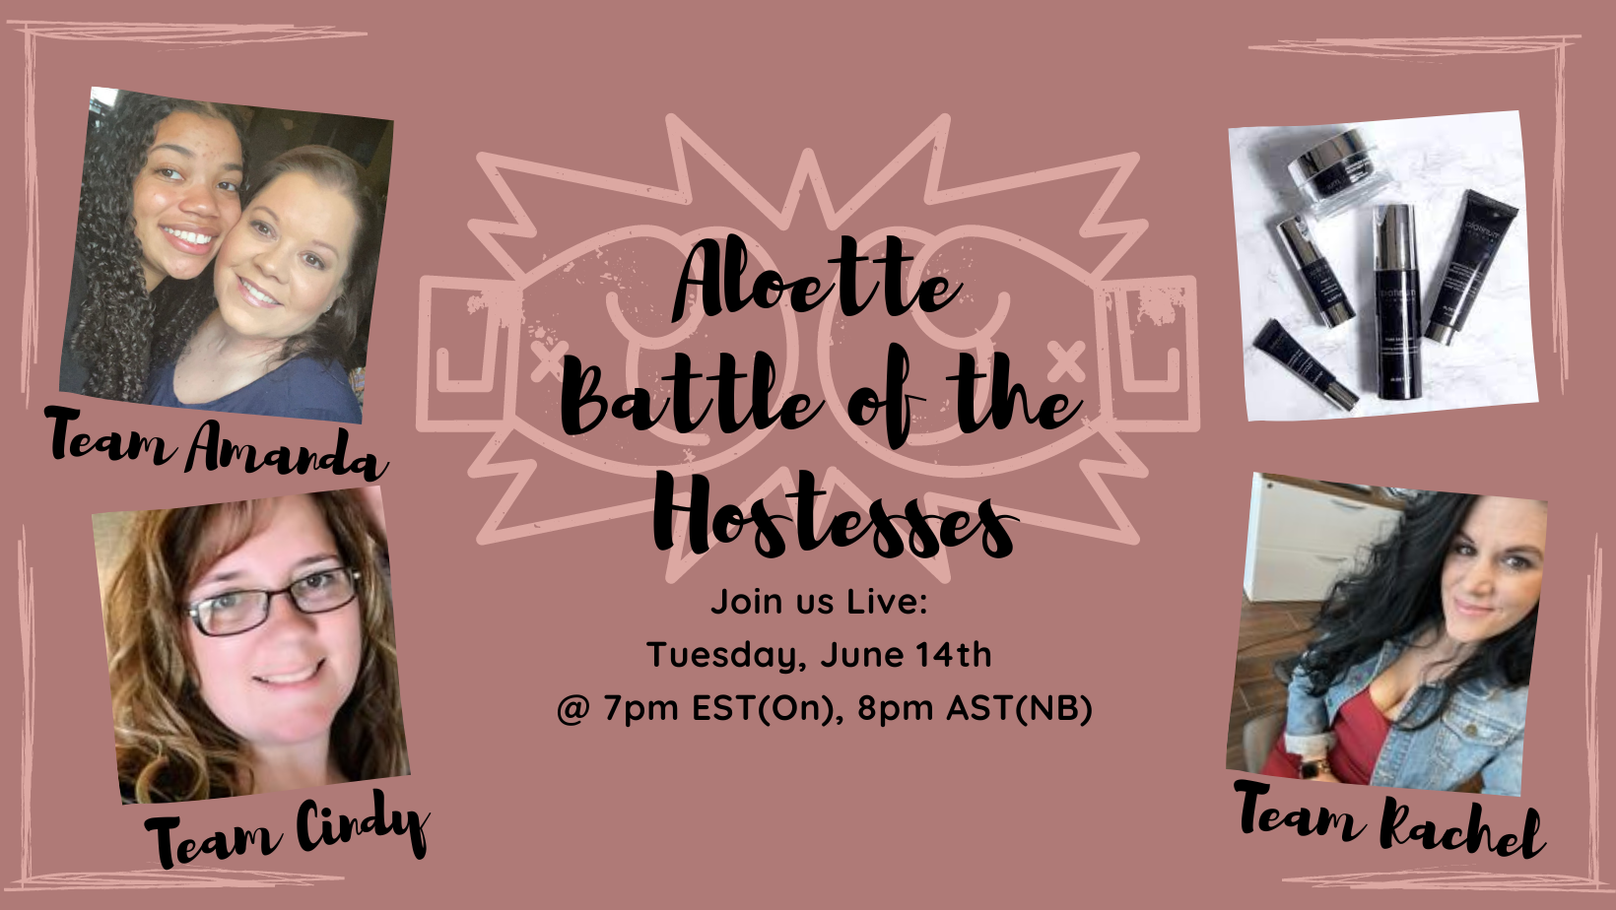

POST 1( Post 4-5 days BEFORE the Party)
Hello, my name is XXXX and I am your Aloette Consultant!

SHARE A LITTLE ABOUT YOURSELF & WHY YOU LOVE ALOETTE

Aloette is a farm to jar company and uses Organic Aloe Vera in our products to help nourish and replenish your skin. We provide custom skincare to help all different skin types that are anti-aging and made without chemical filler, mineral oil, and are not tested on animals. We also have a wide variety of clean makeup too!
Aloette has an incredible ingredient called “Aloeganic”. It is a super high-grade encapsulated aloe vera exclusive to Aloette delivering maximum benefits to the skin. It is certified organic, paraben free and is 3- 10 times more effective than regular aloe in other products and will penetrate deeper into the skin. If your products are not penetrating your skin, they can not help you!

Stay Tuned The Party will be on this page DATE/TIME
(Include a photo of yourself)

POST 2
HAS ANYONE EVER USED A SKINCARE PRODUCT BEFORE AND LOVED IT AT FIRST-BUT FELT LIKE YOU NEVER SAW RESULTS, OR THEY DIDN'T LAST-OR YOUR ISSUES CAME BACK?!
That's where Aloette is unique to anything you've ever tried before-Basically, bc of the ALOE!
We are a certified clean beauty company that is cruelty free and use lots of natural, botanical ingredients...but our Organic Aloe Vera is what sets us apart from the rest!
This aloe is the only natural way to break down to the live layer and skin and fix issues from the inside out! Tired or throwing your money down the drain?! Then I'm so excited to help you figure out what's best for you at the party <DATE/TIME>!
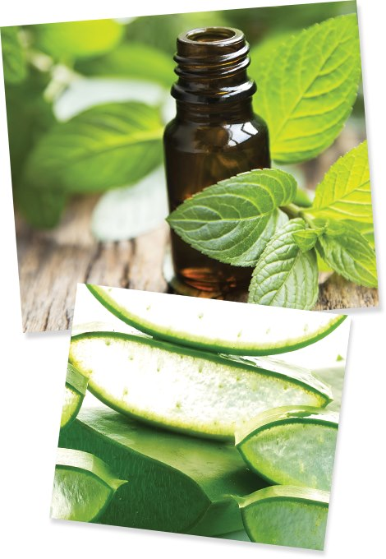

POST 3-

Q

(post This then send a friend request to everyone who has accepted the group)

Post 4
Welcome to the Battle of the Hostesses! Let's have some fun while you support your hostess in winning Free gifts! Comment below with which Team you are on so we can get the line up ready!! Let's get ready to Rumble!!!!!

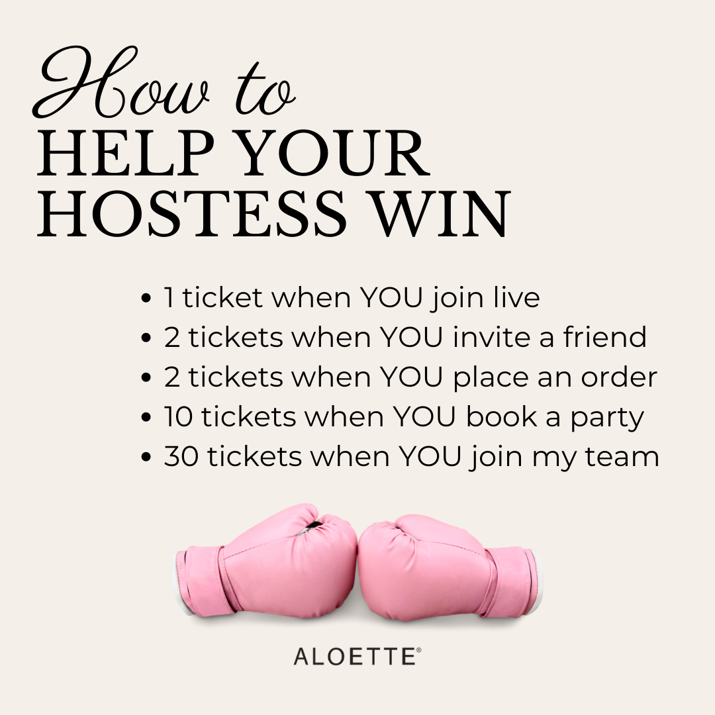

DAY 1

I go live in the group at some point through the day and introduce myself and show them how to change their notification setting on the desktop and show them how to use the ‘features’ section.

Post 1
Be sure to follow these 3 simple steps! Once you have, comment below or add a GIF to say hi to get an extra entry into the giveaway! I even had to change the notifications, and I made the group!!
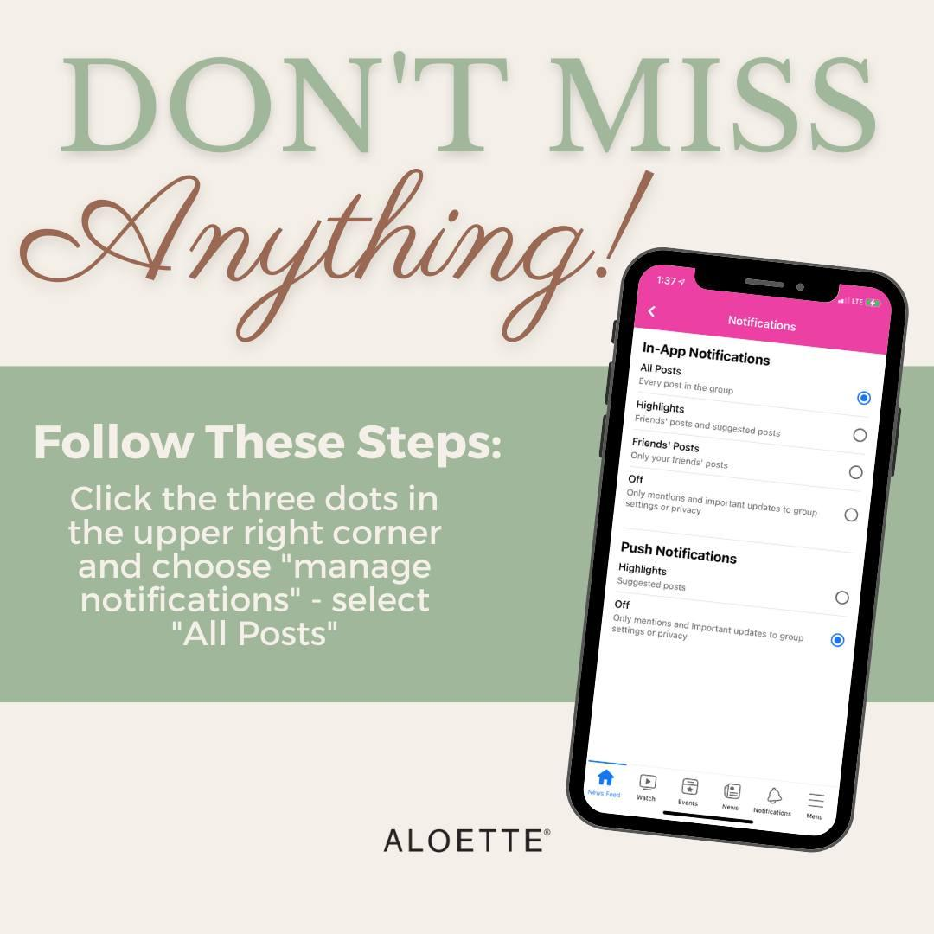

Post 2 - you can add your own story here
It’s never too late to feel beautiful in your skin!
I used to look in the mirror and think I was ugly, disgusting, fat, gross!
My self-talk was really bad, so it’s no wonder I never felt good about myself!

It wasn’t until I joined Aloette that I started changing my inner dialogue and learning about the power of my own thoughts. I am so grateful this company really focuses on helping women feel more confident on the outside using the best products because that will automatically translate to feeling better on the inside.

Now I get to help other women see their true beauty on the outside AND inside!

DATE/TIME I’ll show you how you can feel more confident right here in this group!

What is your relationship with Aloette?
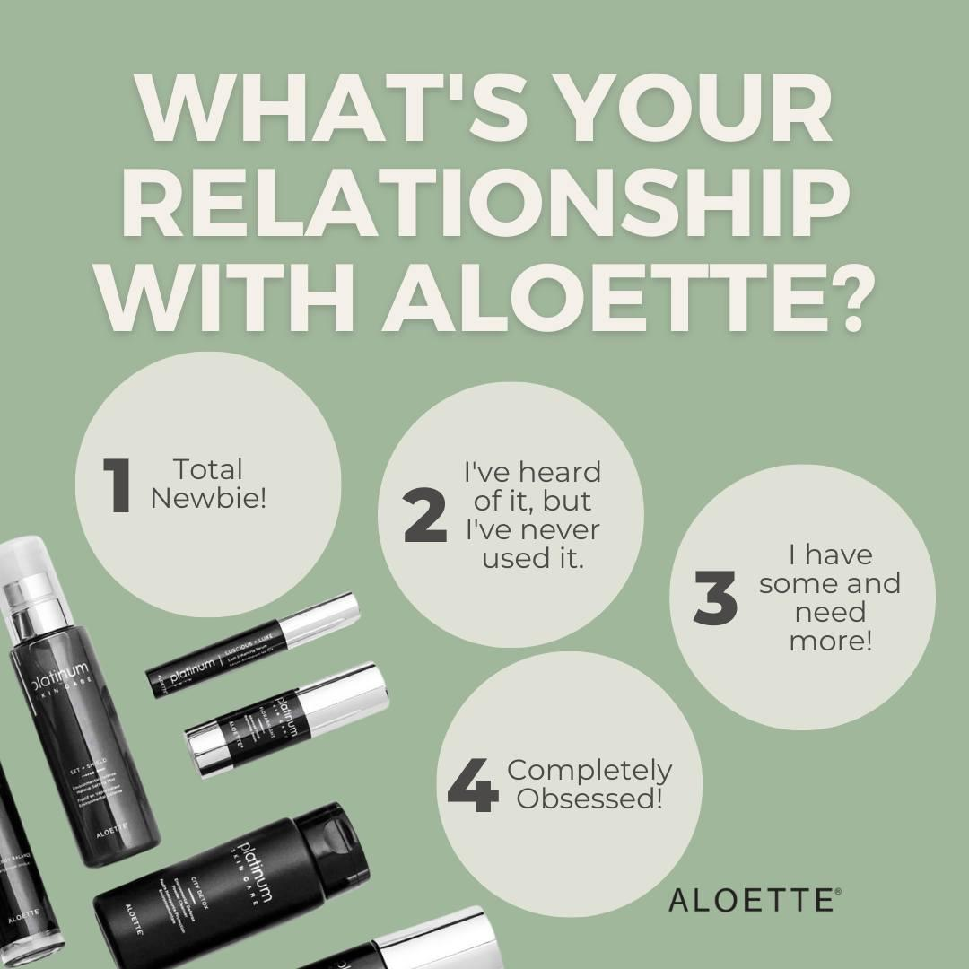

Post 3
ROLL CALL!! How do you know your hostess?

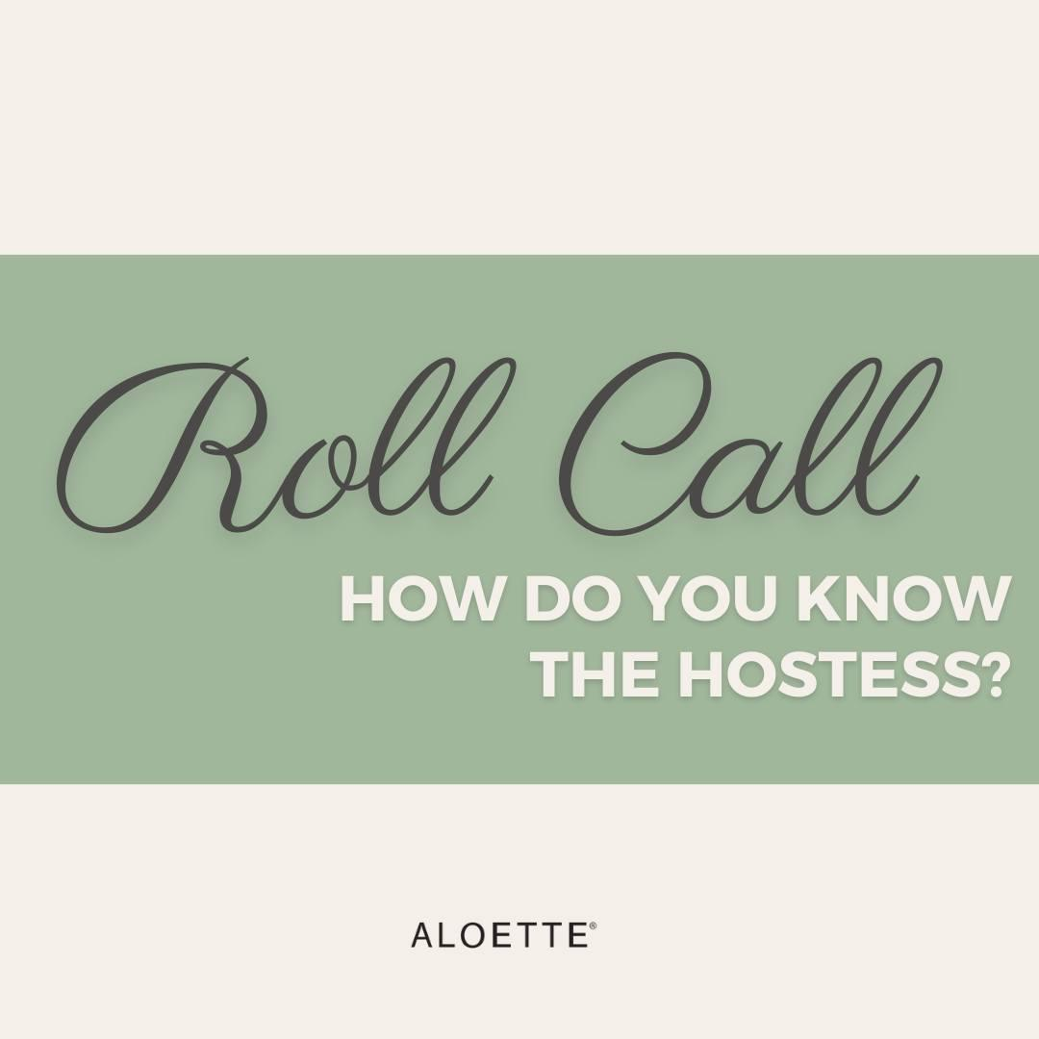

Post 4

Aloette makeup is mineral & vitamin infused which means it’s really good for your skin! It’s free of irritating talc, which is the main ingredient in most makeup lines that clogs pores, dries up skin, and accentuates lines and wrinkles. Yay for makeup filled with good-for-your-skin ingredients!

What makes Aloette even more unique? We offer personal beauty experiences - You don't have to figure it all out on your own!! That's what I'm here for! I offer video one-on-one consultations and can customize your beauty products just for you!

I can’t wait to show you at DATE/TIME for our live portion of this show!

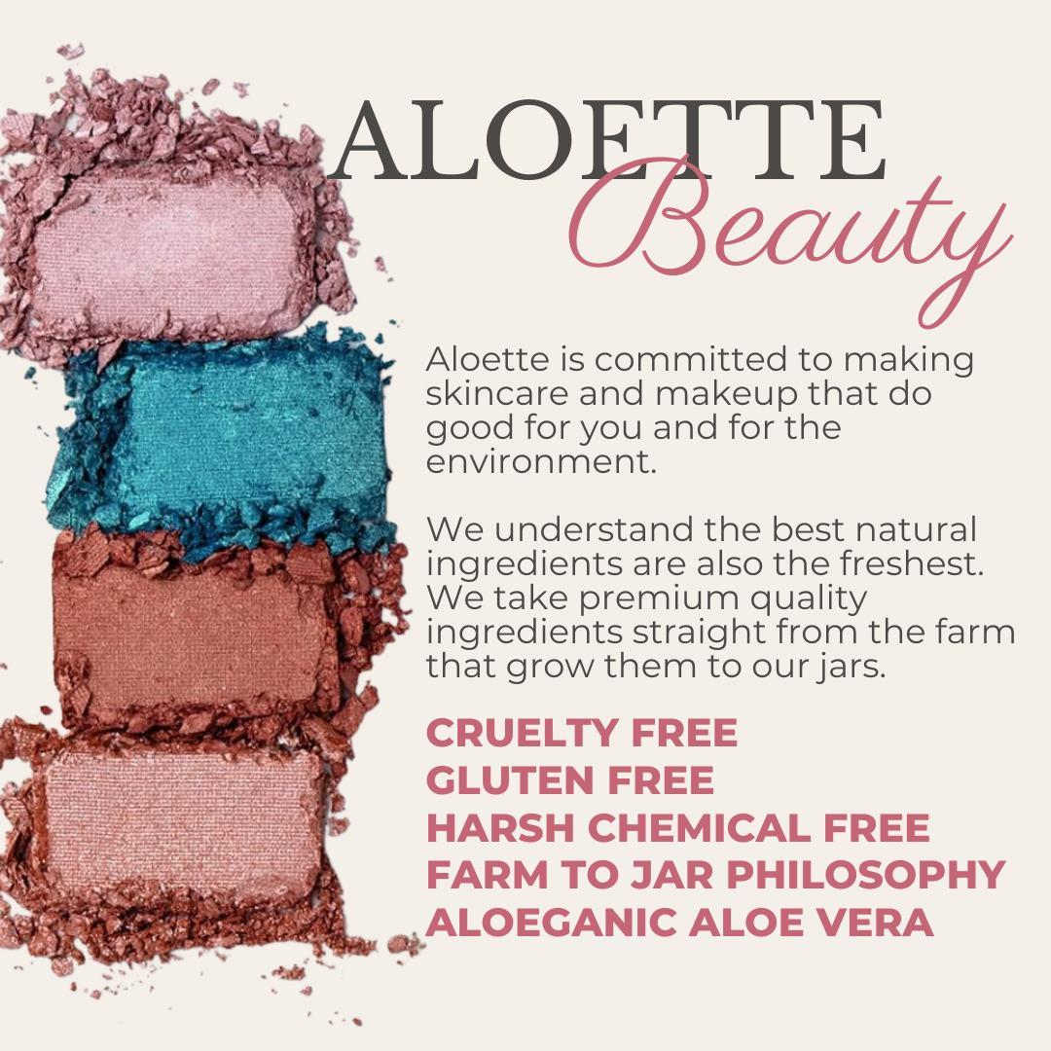

Post 5
Who wants a FREE product?!

Participate in this group and join us LIVE on X -when we have 8 ladies in attendance -I will draw for a FREE PRODUCT!!

Post 6

]”?0
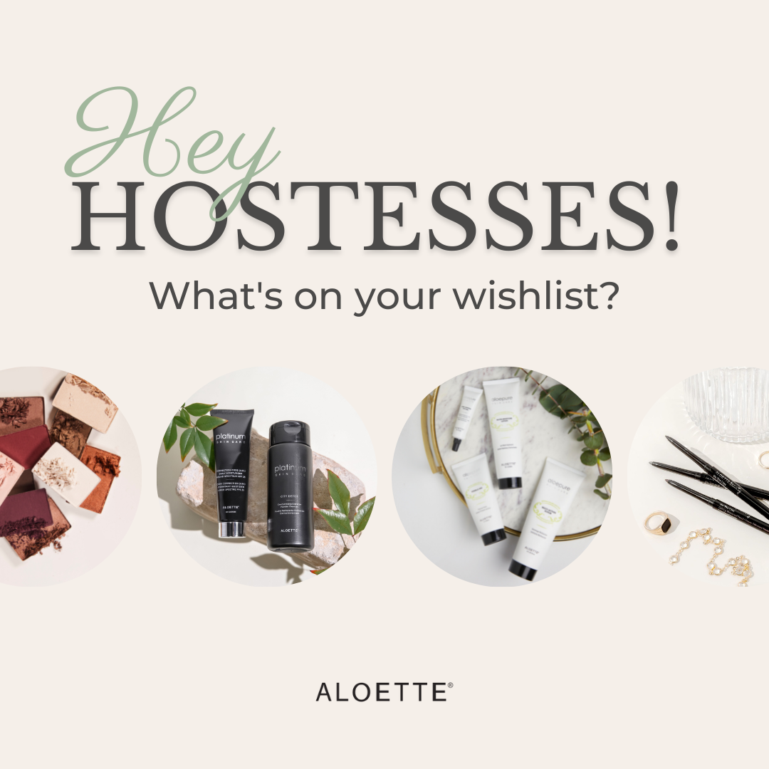

DAY 2
I go in and message every guest who has accepted the group invite and say this:

Hey <NAME>! I wanted to drop in and introduce myself. My name is <YOUR NAME>. I am <HOSTESS NAME>’s friend and Aloette consultant who will be hanging out with y’all on <DAY OF PARTY>! Have you ever heard of Aloette before?

Usually they respond no so I say- “Oh my gosh you are going to love it! Will you be joining us on <ZOOM/FB LIVE> <DAY OF PARTY> at <TIME OF PARTY>?
If they respond yes- “Awesome! I am so excited for you to join us! Do you have any skin concerns?”
- If they respond yes-
  - “Ok. I will be sure to write that down!
  - <ZOOM ONLY> “Let me know if you need help using Zoom! Also- be sure to invite a friend. When <hostess> gets 8 ladies to join her on Zoom, she will get <INSERT GIFT> and YOU will get a special gift from me too!
  - <FB LIVE ONLY> “We will go live right here in the group. Be sure to invite a friend to the group! When she joins you live on FB, you will get a special gift. Be sure to comment and let me know when she joins on our fb live!
- If they respond no- Awesome!! I can’t wait for you to join us. It is going to be so much fun!
  - <ZOOM ONLY> “Let me know if you need help using Zoom! Also- be sure to invite a friend. When <hostess> gets 8 ladies to join her on Zoom, she will get <INSERT GIFT> and YOU will get a special gift from me too!
  - <FB LIVE ONLY> “We will go live right here in the group. Be sure to invite a friend to the group! When she joins you live on FB, you will get a special gift. Be sure to comment and let me know when she joins on our fb live!

If they say they have heard of Aloette, ask if they have ever used it.
- Awesome!! I can’t wait for you to join us. It is going to be so much fun!
  - <ZOOM ONLY> “Let me know if you need help using Zoom! Also- be sure to invite a friend. When <hostess> gets 8 ladies to join her on Zoom, she will get <INSERT GIFT> and YOU will get a special gift from me too!
  - <FB LIVE ONLY> “We will go live right here in the group. Be sure to invite a friend to the group! When she joins you live on FB, you will get a special gift. Be sure to comment and let me know when she joins on our fb live!

Post 1

Hey Beautiful Ladies! Let's chat aging for a sec. I mean, it's the one thing we all do-bc the alternative is, well- deadly LOL
BUT we all want to age gracefully right?! That's why skincare matters! Using a great cleanser, exfoliator and moisturizer with sunscreen are your barebones basics for healthy skin.
But I DO have a little weapon in my arsenal that is AMAZING I want to share:

AGELESS SCIENCE!
Y'all...this stuff instantly plumps, firms, tightens, tones, and brightens the appearance of your skin! It has instant results, BUT the longer you use it, the better your results are! Use it daily until you achieve your desired results, then a few times a week to maintain them after that. It's packed full of hyaluronic acid and matrixyl synthe' 6 - both extremely "high performing" ingredients!!
It's the most expensive product in our line. (I mean, HELLO it's basically a facelift or injection without the blade/needle LOL) and retails for $210!
BUT- when you join us TOMORROW AT <TIME>, I will share how you can snag this bad boy for 80% off and only pay $39.95!!!

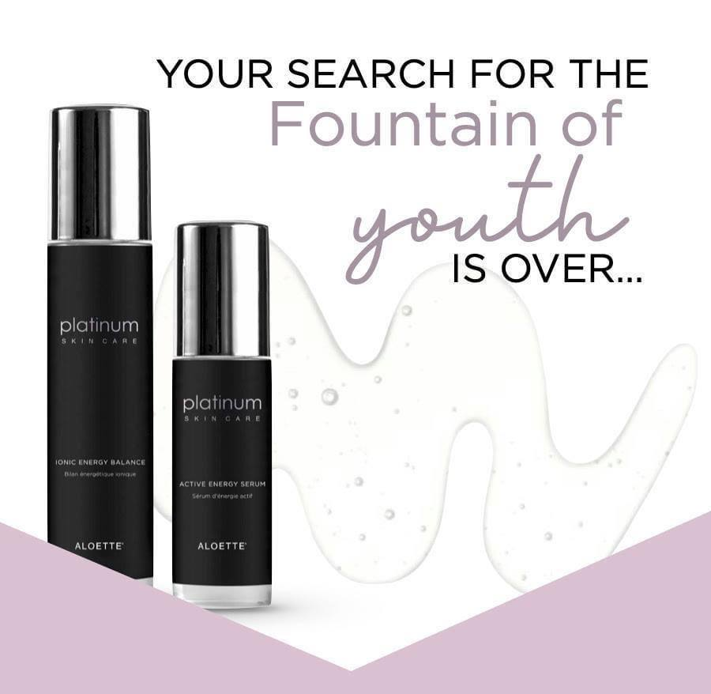

Post 2
One of the things I love most about my job is when my clients see real results with their Aloette products! I'll be able to help you privately when you come to <HOSTESS> girls night tomorrow! That way, we can get the best products for you, your skin type and your lifestyle. But maybe give me a head's up here! What would you like the most help with for your skin? Our skin can change seasonally so that may be an issue for you right now too!
Comment below for an extra entry into the giveaway!
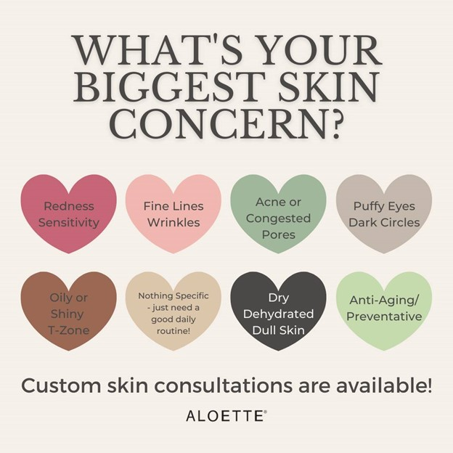

Post 3
Real People. Real Results.
Our ALOEGANIC Aloe soothes the skin to help even out skin tone and soften the appearance of lines and wrinkles. We have products for every woman whether you are looking for anti-aging, correct discoloration in the skin, or simply keep your skin healthy and strong.
I can't wait to help you find the perfect products for your skin type and help you achieve your skin goals.
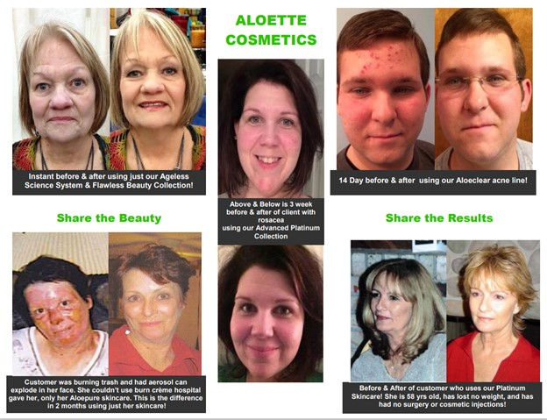

Post 4
Pre-book your date before the party & receive a BONUS gift from me! And you’ll be giving <HOSTESS> a $100 shopping spree to come spend! Only 3 bonuses to give away!!

Post 5
​​Sensitive to Aloe Vera? Maybe you're even allergic?
No worries, I got you! Here is a list of products that do not contain our Hero Ingredient so that you too can party with us.
I will say that I've had people use my products who previously couldn't use 'aloe vera' due to sensitivities. Pretty confident it's because aloette doesn't use the whole plant chopped up like a filler-- we just use the encapsulated acemannan (the gel).
The more we know: Acemannan (ACE) is a -β(1→4)-acetylated polymannose present in the inner leaf gel of Aloe vera plant, a medicinal plant. ACE has been described by its multifunctional properties such as immunomodulatory activity, antiviral, antioxidant and antibacterial actions. Therefore, ACE acts as a bioactive molecule, exerting an immunostimulatory effect by activating macrophages and wound healing actions.

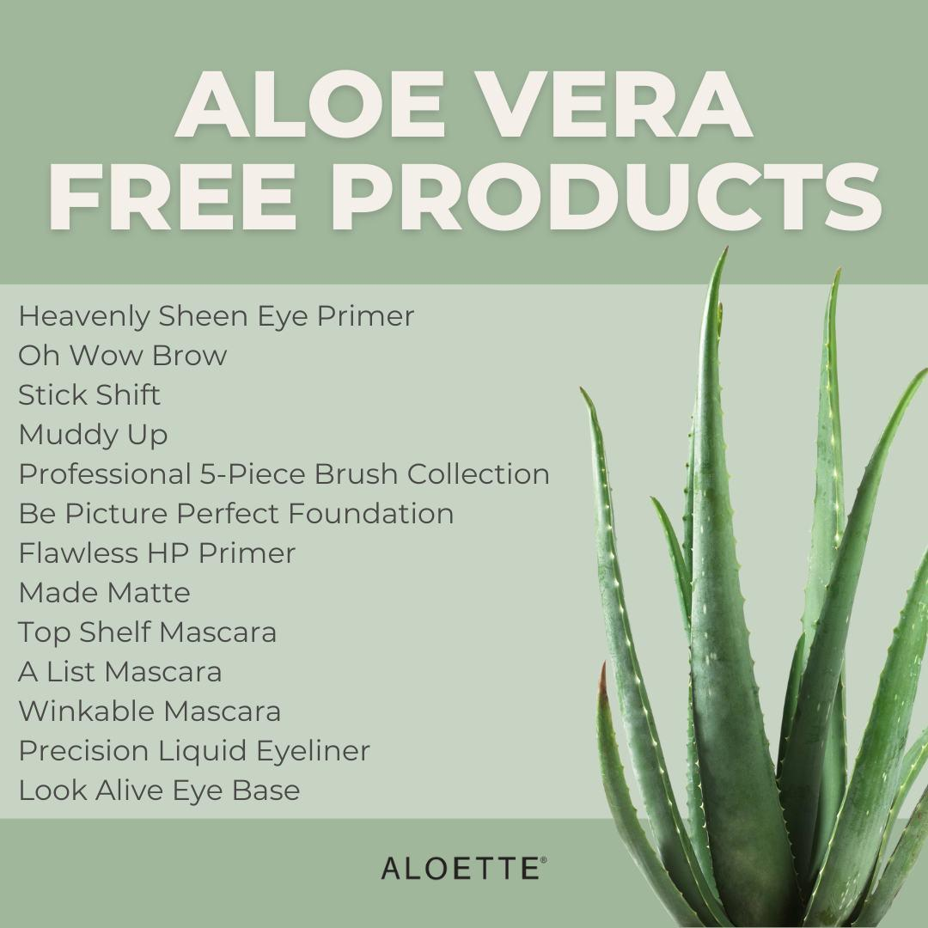

POST 6 ( THIS GAME IS OPTIONAL)
Let's play a quick game before we go LIVE tomorrow night!
Take a guess at the number of chocolate covered raisins that fit in a Nutri-Hydrating Mist bottle!!! DO NOT ANSWER ON THE POST -- PM me with your answer!!!!

–ANSWER IS 97–
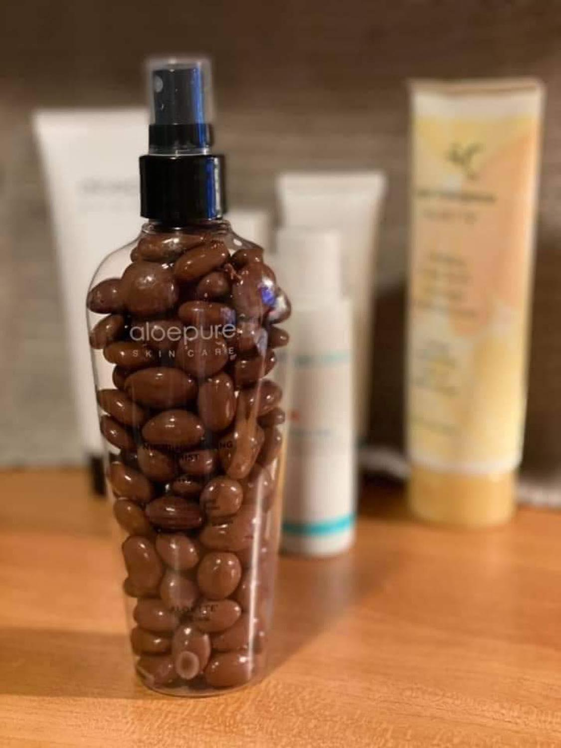

DAY 3 (Day of the LIVE)

Post 1
Tonight at <TIME> (be sure to specify time zone) is The Battle of the Hostesses GIRLS NIGHT!!!
I can't wait to show you how to have healthy, glowing skin <3
My #1 priority is to help other women feel their absolute best on the outside as well as the inside. The most important person to take care of is YOU. As mothers, wives, caregivers & professionals, we play many roles and wear many hats which often places us at the bottom of the list. Tonight is for YOU, tonight is for you to sit back, relax, grab a beverage and have some FUN!!
TONIGHT I will show you how you can pamper yourself in 2 mins- YOU ARE WORTH IT!!

Post 2
WOOO! TONIGHT IS THE NIGHT! It's time for the Battle of the Hostesses GIRLS NIGHT at TIME!! Where will you be joining us from? The Pool, your deck? The couch? Maybe you will be out on a walk?

Post in the comments

Post 3
This Visible Aid Cream is AMAZING and has so many uses!! This has been one of our best sellers for over 40 years!!! I can not wait to share more about this tonight at <TIME>!!
Hint: I may have a way for you to get this for free

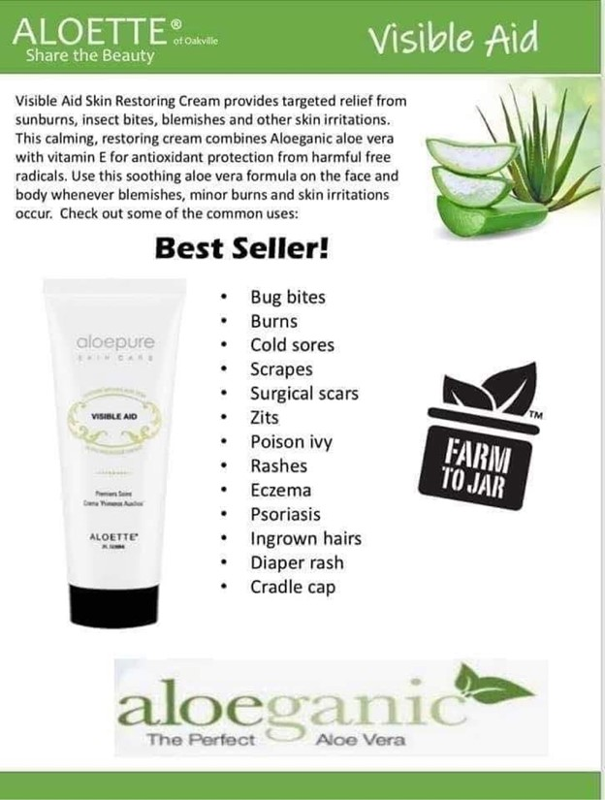

Post 4
Here is my personal Skin Transformation with Aloette.
- TONIGHT at TIME I am going to show you how you can also achieve amazing results using Aloette.

Can’t wait!! Xo

(Use your own transformation OR you can use a customer/consultant Transformation)
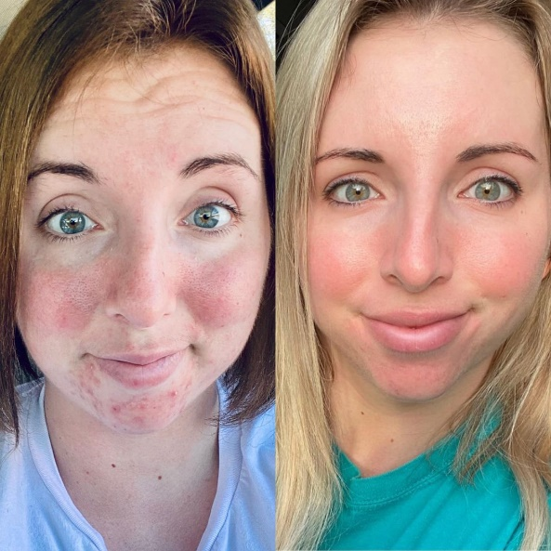

Post 5 (post 1 hour before live show)
See you in ONE hour!! It’s almost time to relax, unwind- we both know you deserve it!

Come as you are!! You’ll be glad you joined us on FB live!!
Don’t forget your beverage and a piece of paper and pen!

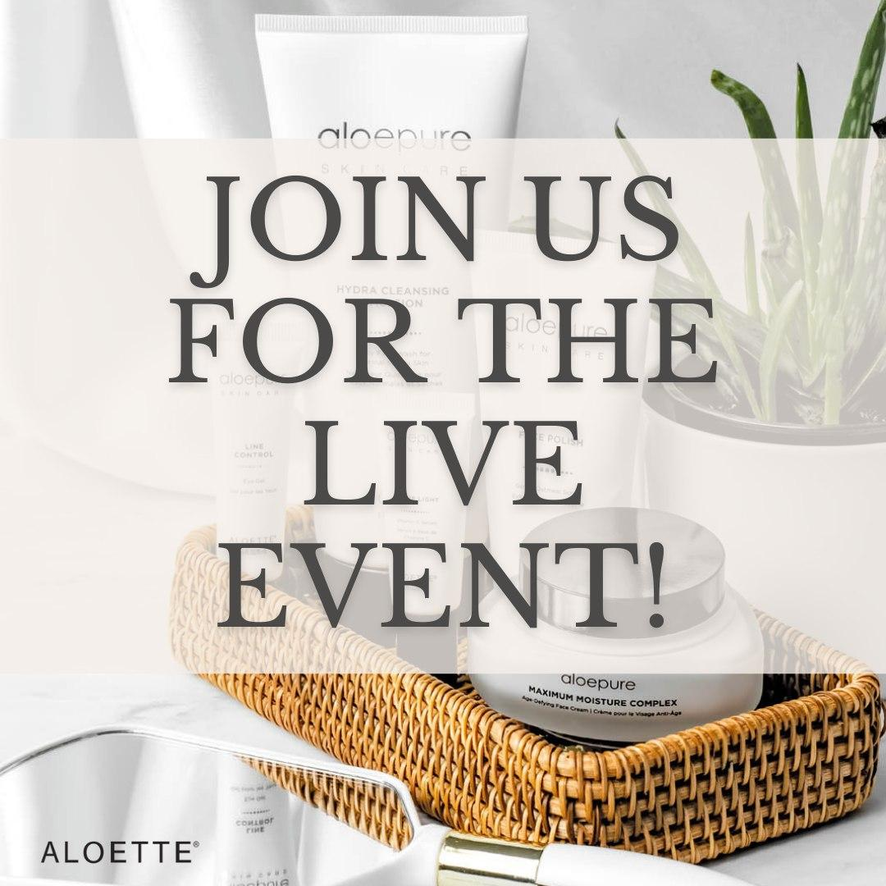

Post 6 (Post 15 mins before live)
Gahhh so excited- 15 MINUTES LADIES. Grab your drink, pen and paper and get ready to learn about skincare and skin health <3 No makeup, no bra, no pants--- no problem!!!

Post 7 (Set to post when show ends)
Are you ready to feel your best in your skin!? Are you ready to put your own oxygen mask on first and take care of YOU?!
Please let me help you to take away the guesswork. I will customize and ensure we get you the right package for your skin, age & of course work with your budget!
CONTACT INFO HERE
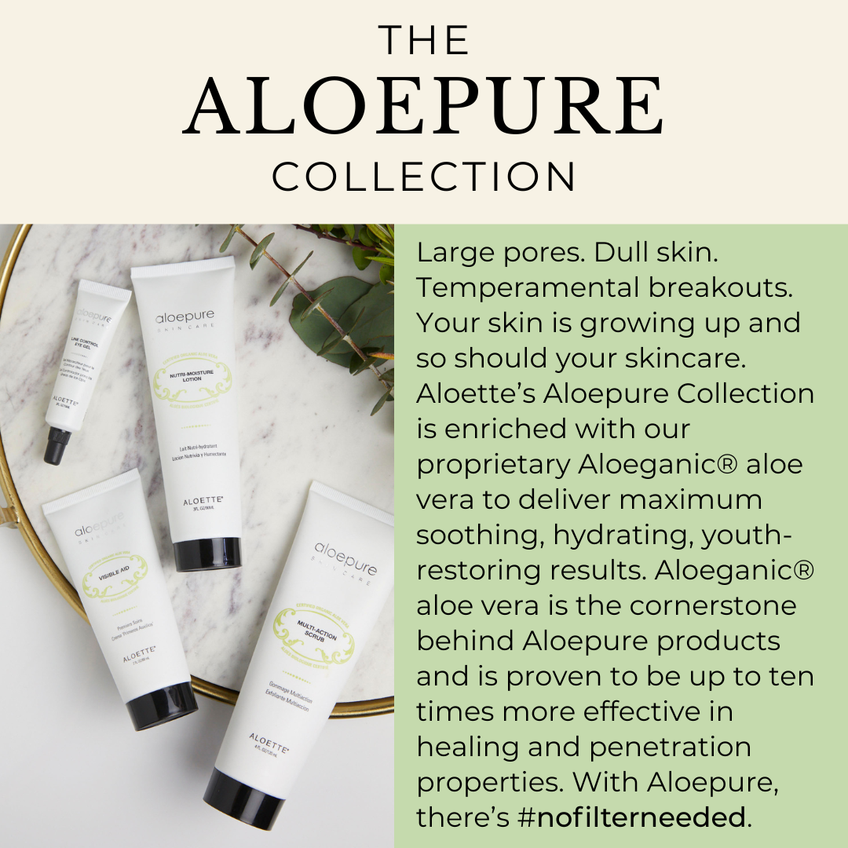
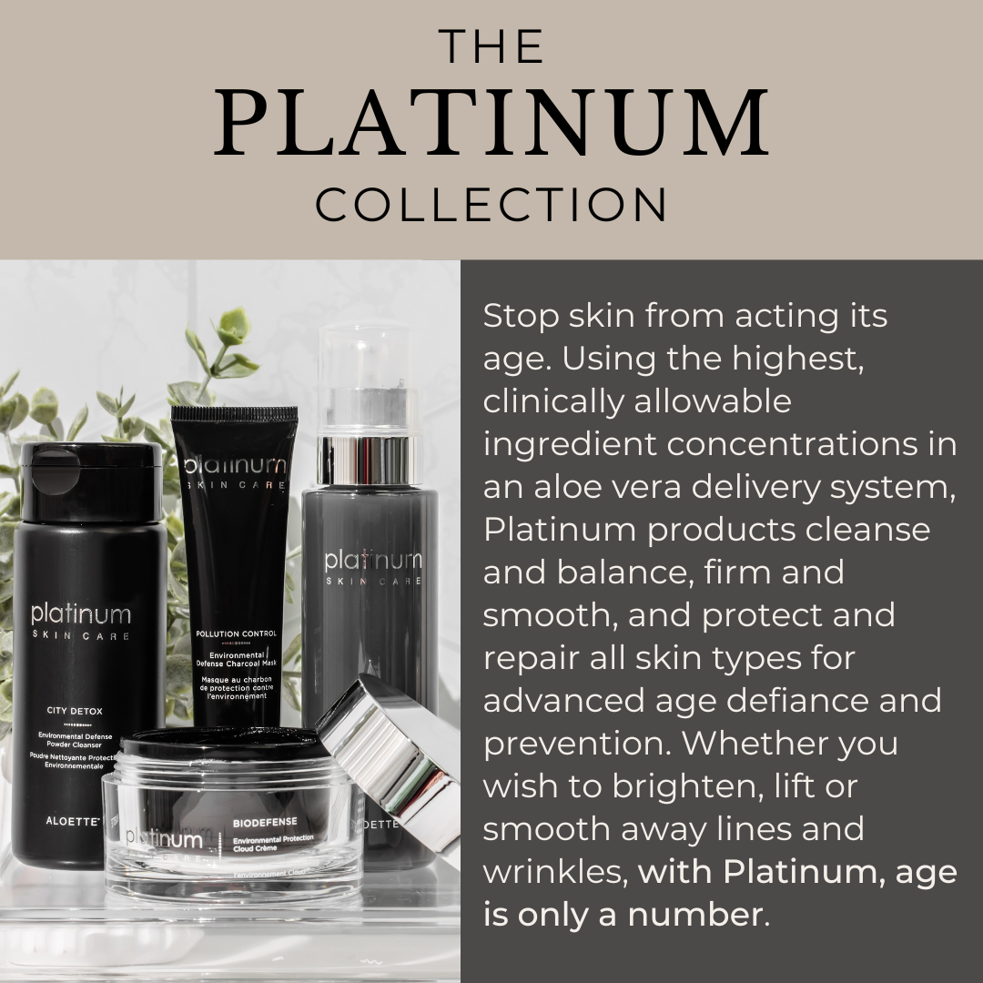

SHARE ANY PROMOS/SKINCARE COLLECTION SQUARES HERE, TOO!
a1q`

Post 8 ( 30 Mins After LIVE SHOW)
Couldn't make the live event? No problem!
Questions? Just message CONTACT INFO HERE

I highly recommend you check out the live presentation replay!! You'll learn SO much more about the product and how they can help you!
Benefits of ordering through me directly - I can ensure we get you the right product, best deal & possibly save on shipping!

RIGHT AFTER THE SHOW

Message Hostesses-
(In a voice note)
Thank you so much for having me tonight!! I had so much fun sharing Aloette with you and your guests. I’ll keep you updated on show sales and where you are for your hostess credits. Can you please message anyone who attended the show to thank them :D and can you send the following message to the ladies who did not attend :

(In text)
“I'm so sorry you missed my Aloette show!! However, there is a replay available. CONSULTANT NAME will be reaching out in the next 24 hours. Her cell number is NUMBER you can text her anytime. We close the party on DATE/TIME. Please let me or CONSULTANT NAME know if you have any questions. Thank you for joining my Aloette Party group :D”

Go live in the group and wash your face so they can see the products in action!

MESSAGE GUESTS WHO WERE LIVE RIGHT AFTER THE SHOW

Message Guests
Hi NAME! Thank you so much for joining us tonight!! I would love to hear what you thought about the show?

Day 4 (Day After live show)

For Guests that were not on- Hey NAME. We were sorry to miss you last night at xx’s Aloette party. The replay is available, but I can also help you answer any questions you may have! Have you heard of Aloette before?

COUPONS
POST AND THANK PEOPLE AS THEY ARE ORDERING….
Use this image for rewards- 2 or more bookings, 8 guests on party, $100 in outside orders, etc
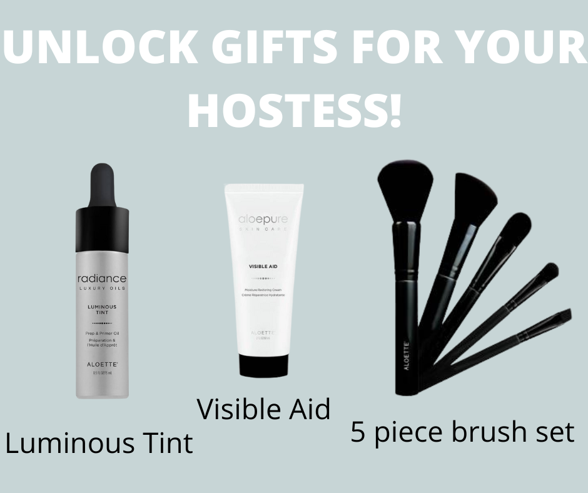
IF ANYONE BOOKS A SHOW POST THE UNLOCKED MONEY PICTURES

Post 1

SHOW ME THE MONEY!!!
What would you do with an extra $500-$1000 a month? Renovations? Buy a new car? Go on a shopping spree? Put your kids in karate or dance? ---- there is no wrong answer.

WHATEVER it is that YOU want to do with some extra cash- Aloette is the vehicle that can help you earn the money for the things YOU want to do! Our average consultants earn $75- $100 PER SHOW- LADIES THIS IS ALL ONLINE- if you want more info- let’s chat.

POST THANK YOU GRAPHICS WHEN PEOPLE ORDER - please remember not all people are comfortable with WHAT they ordered posted on Facebook, so a generic Thank You is best unless you confirm with the guest first.
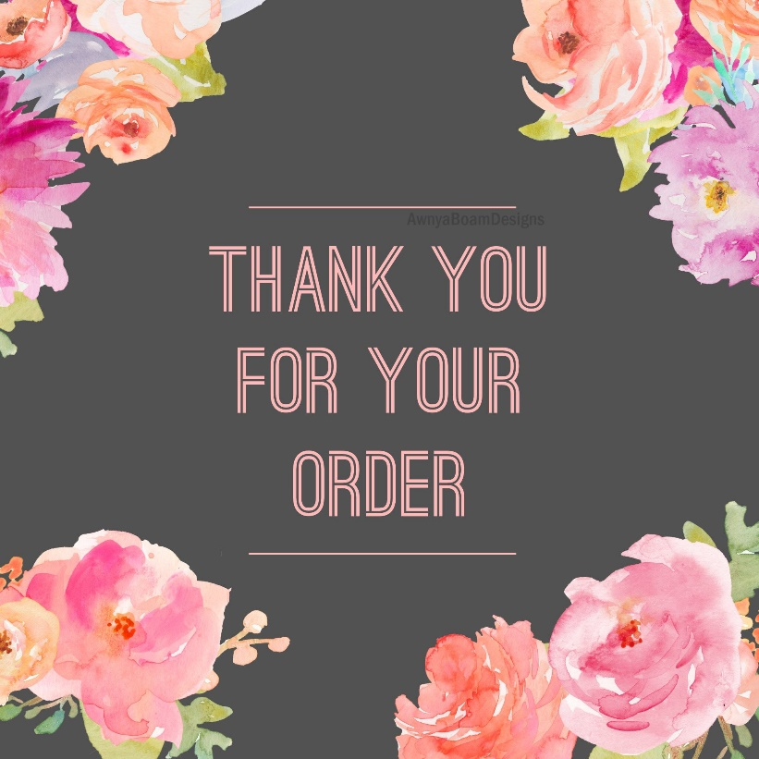

Post 2
Messages have been sent out ❤ Check your "Message Requests" folder and click on "Spam" or “request” If you don't see my message in your inbox 😁

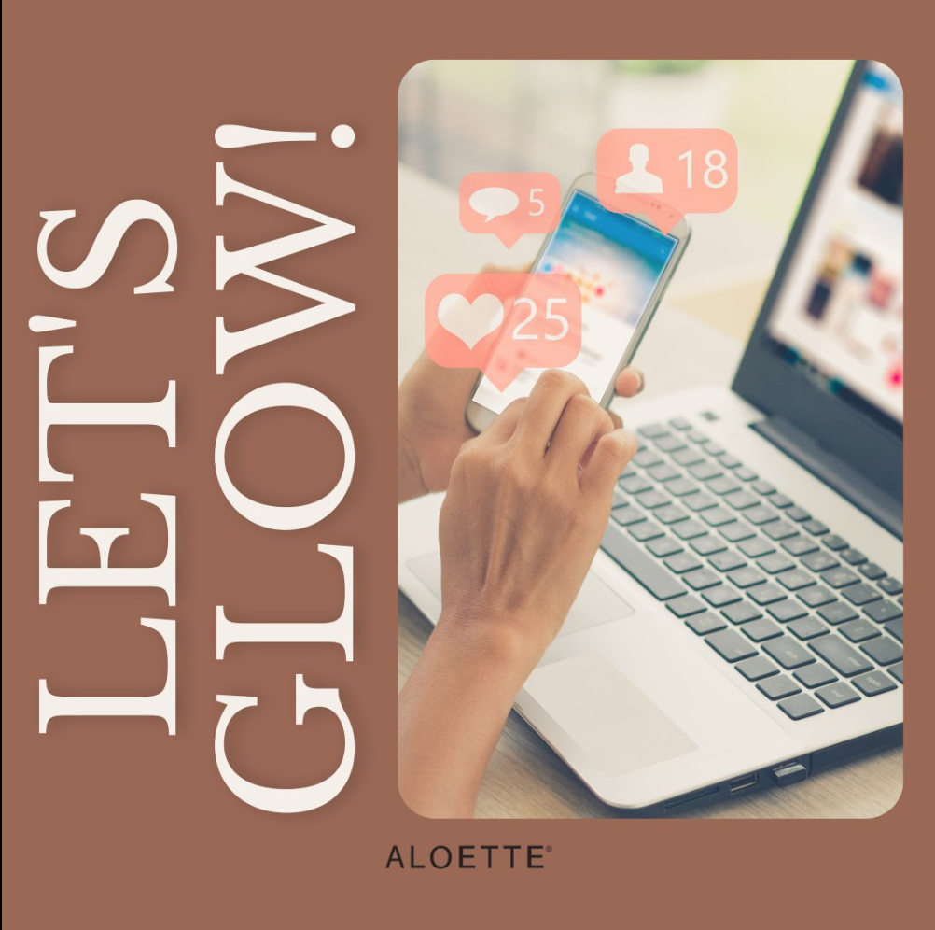

Post 3
Just checking in! Comment with where you’re at!! The party will end Tomorrow at <time>.
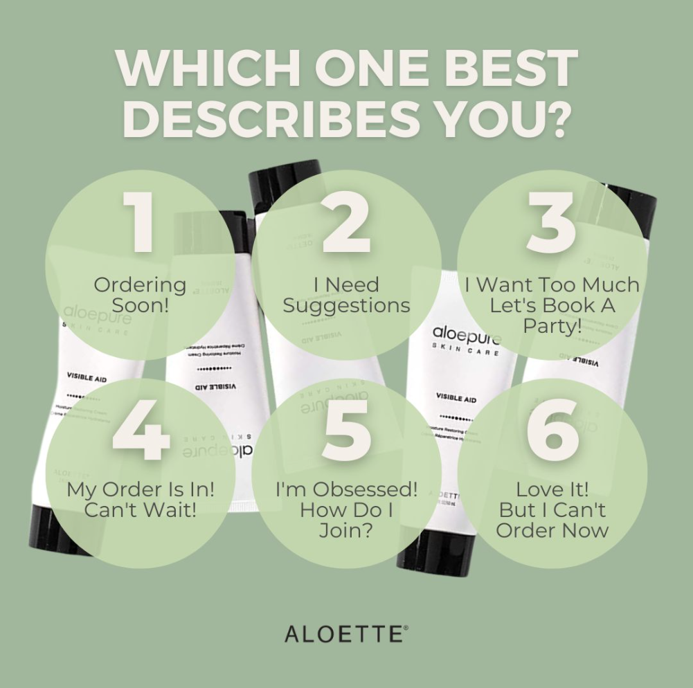

Day 5

MESSAGE HOSTESS TO WRAP UP PARTY

I am wrapping things up and finalizing orders tomorrow at TIME.
Some ladies haven’t seen my message - this is totally normal! Facebook may have sent my messages to a hidden folder because we’re not direct friends. I want to make sure you get credit for all of your orders for your hostess credits and that no one misses the deadline! Too many times I’ve had guests message me too late who had wanted to order. I suggest you message each guest who responded that they wanted to attend.

You can copy/paste this message to your guests:

”Hey!! Thank you so much for joining my Aloette Party group. I am not sure if you seen Andrea (Aloette lady) tried to message you. Did you see her message?”

MESSAGE GUESTS TO WRAP UP PARTY
For those who have not responded,

Hey <NAME>! I just wanted to let you know the party will close tonight at <TIME>. I just wanted to check in and see if you had any questions or if you were interested in placing an order or booking a girls night to help <HOSTESS>.

Post 1
Skincare Excuses/Beliefs that don’t serve you
Can you relate to any of these? Let’s debunk!

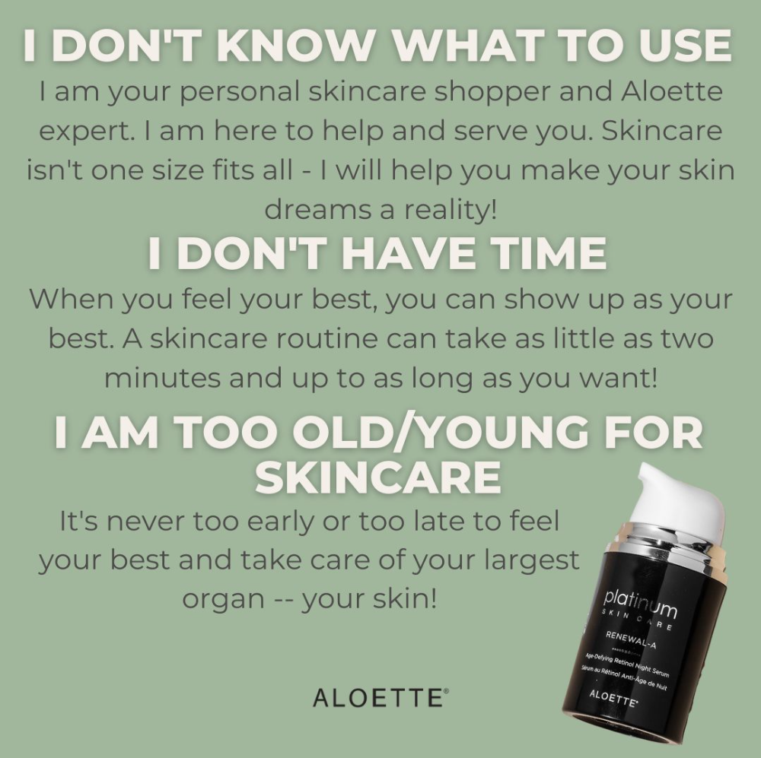

Post 2
Aloette is a very unique business opportunity unlike other home-based businesses.
LOW START UP COSTS! You will receive FULL training & support.

The flexibility of working when you want, on your own terms, around your family is why many women are joining my team right now! Sounds too good to be true? IT IS! Nothing to lose & everything to gain!
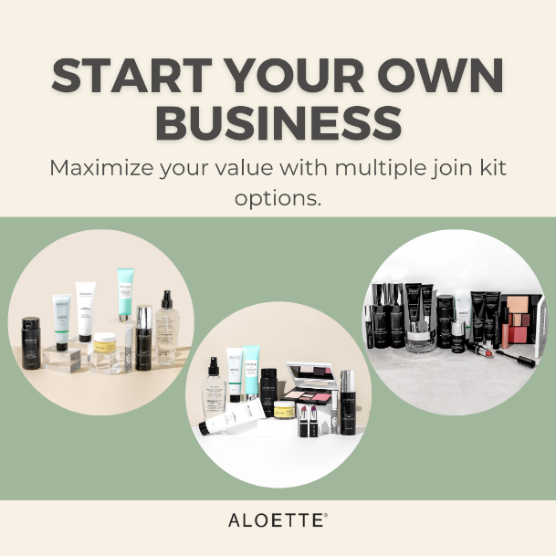

Post 3
Are you ready to feel confident in your skin!? Are you ready to invest in you so you can become the best version of yourself?!
Please let me help you to take away the guesswork. I will customize the best routine for your skin, age and work within your budget!
CONTACT INFO HERE

Post 4
Check out our incredible hostess rewards! It ends up being 400-600 dollars worth in product on average for 80-90% off!
I set everything up for you, it's simple, easy and you get to have a true girls night with them! Let’s help your friends with their beauty needs in the comfort of their homes too. Plus - you’ll be unlocking more hostess rewards to your host!! She’ll come with her 100 dollar coupon to redeem.

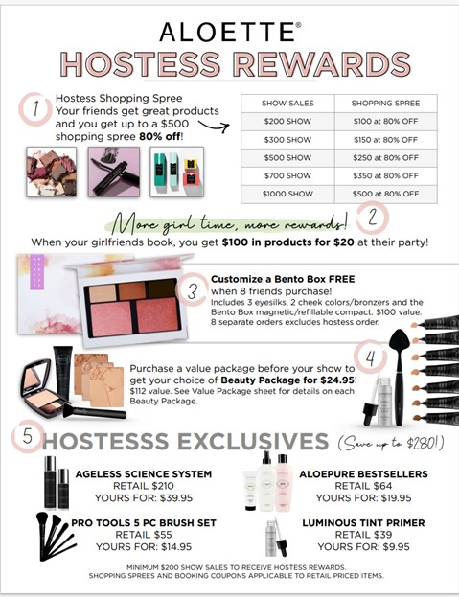

Day 6

Post 1
Need I say more? You have until TIME Tonight.

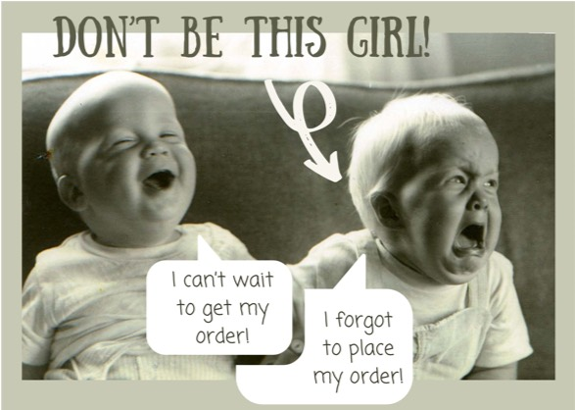

Post 2
Join my Client VIP Community -- This is where all the cool stuff happens!
🎉 Tutorials and Product Tips!!
🎉 Giveaways!!
🎉 Exclusive Deals!!

Just click on this and request to join!!!
(4) Simply Self Care-Noel’s VIP Aloette | Facebook
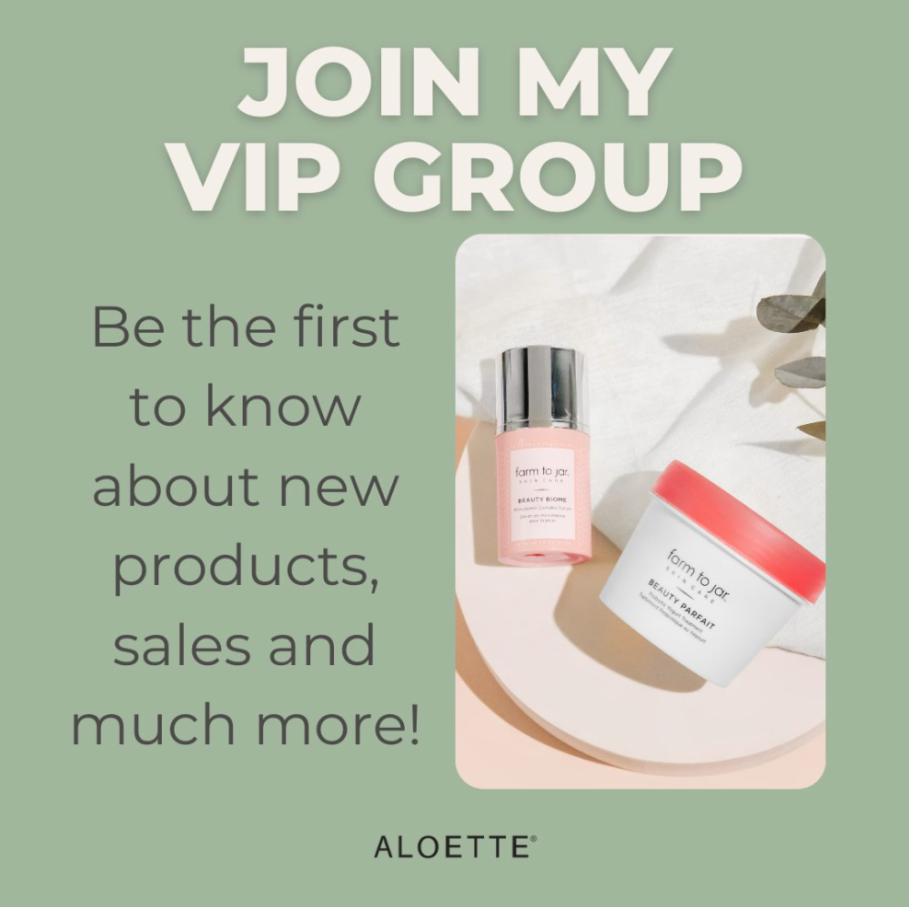

DRAW POST FOR FREE PRODUCT
Congratulations NAME! YOU are the GIFT WINNER!!!

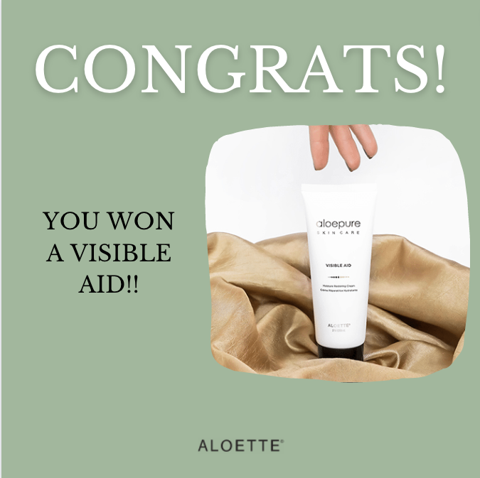

CLOSING POST
The show is closed off and orders are entered. THANK YOU again everyone who ordered! Because of you <HOSTESS> earned <THIS AMOUNT IN REWARDS>! Your order will arrive in approximately 1-2 weeks and I will be checking in to make sure you got everything in good order!

I’m your Aloette Beauty Consultant, I am here to help and serve anyway that I can!

If you were the consultant doing this show you would have made $X!! If you would like more information- message me :D

